**Beginner Notes**

* Lakes are usually a good option for beginners because there are banks and insets to catch hungry fish
* Common fish species found in lakes: trout (brook, brown, rainbow), panfish, bass (largemouth and smallmouth)
* Before visiting, you must know if the place you plan to fish at is a catch & release, artificial lures only and if it’s fly fishing only
* Bait for beginners are usually live worms or power bait (scented putty material that is formed around the bare hook)

**Fishing Pole Weight**

UL - Ultralight

L - Light

ML - Medium Light

M - Medium

MH - Medium Heavy

H - Heavy

UH - Ultra Heavy

**Fishing Techniques**

Jigging & Saltwater Jigging

* Most active fishing methods
* Requires angler to snap or pop the rod trip quickly to move the lure vertically in the water column.
* When learning, angler can either jig straight and down or casting the lure out and jig it back towards angler horizontally while reeling

Still Fishing

* One of the simplest and most effective fishing methods for beginners
* Can still fish from pier, bridge, anchored boat or from shore
* Put the bait in the water and wait for the fish to find it.

Bottom Bouncing

* Modified form of drift fishing or trolling
* It’s an effective way to attract fish and cause them to strike or start feeding
* Done from drifting or trolling boat; it’s a great way to attract or locate fish during most seasons and times of the day
* Use a bucktail jig or natural bait and drag it along the bottom

Drift Fishing

* This method allows anglers to fish over a variety of habitats as the boat drifts with the currents or wind movements
* Drift on the bottom or change the depth with a bobber or float
* Natural bait works best with this method, but jigs, lures and artificial flies produce good results as well.

Surf Fishing

* Fishing from the beach

Fly Fishing

* Angling method that uses light weight lure known as artificial fly to catch fish
* Fly is cast using a fly rod, reel and specialized weight line
* Can be done in fresh or saltwater
* Difference between fly fishing and bait fishing is that the fly fishing line carries the hook through the air whereas in bait fishing the weight of the lure sinks.

Upstream casting

* cast upstream using in-line spinners for brown trout or rainbow trout
* Natural food sources will be drifting downstream

**Bait**

Saltwater Bait

* Crabs
* Cut bait - cut up baitfish
* Clams and mussels
* Shrimp (one of the best saltwater baits)
* Squid

Freshwater Bait

* Cut fishing bait
* Leeches (excellent for walleye and northern pike)
* Dough balls (prepared fishing bait) - commercially made, come in a can and are labeled for specific fish. Mold the dough around the hook.
* Grubs and mealworms (ideal for panfish, sunfish and trout)
* Minnows aka baby fish - use larger ones for bass and pike fishing
* Insects - ants, beetles, grasshoppers, crickets, caterpillars

Brown trout are attracted to ants presented on a fly

Small mouths and large troue prefer mayflies, stoneflies, caddies, hellgrammites and dobsonfly larvae

* Freshwater clams and mussels
* Crayfish aka crawfish

For smallmouth bass, use crayfish whole and alive hooked through the tail

Panfish use the tail meat or meat from the large pincers

Catchfish, bullheads and carp use dead crawfish threaded on a hook

* Freshwater worms
* Eels (especially good used whole when trolling for striped bass) - can be used whole or cut into chunks
* Cured fish roe - salmon or trout eggs are considered the best bait for salmon, steelhead and trout

**Lures**

Freshwater Fishing Lures

* Fishing jigs - can be used to catch nearly every kind of freshwater and many saltwater fish

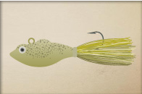

* Poppers - very good for panfish, trout and bass

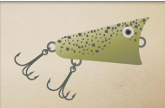

* Spoons - minimic the action of a swimming baitfish or minnow; one of the most popular of all freshwater fishing lures because it is easy to use and are versatile

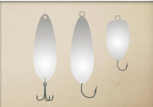

* Plugs - designed to be used on top of the water or at depths below the surface - often called crankbaits

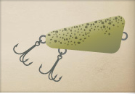

* Spinners

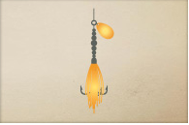

* Plastic baits - soft plastic worms, minnows and crayfish; can be used with or without weights
* 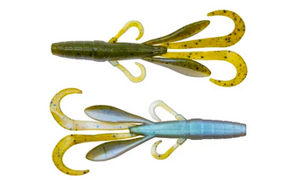
* Spinner baits

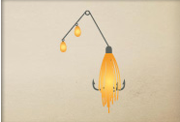

* Surface fishing lures - made to imitate things like mice, lizards, frogs, larger crawling insects and smaller injured fish.
* 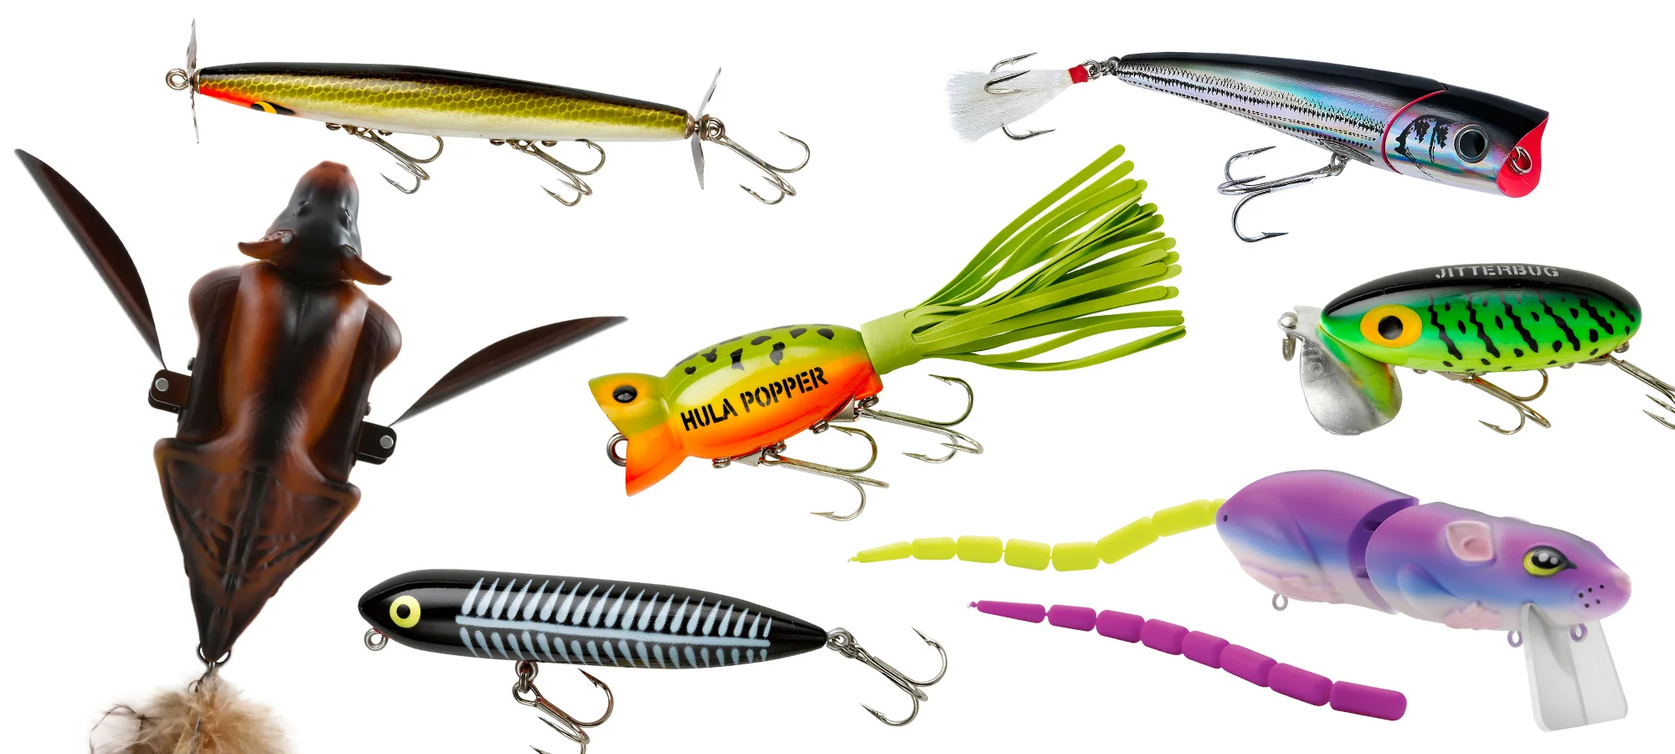
* Blade fishing lures - popular freshwater trolling lures

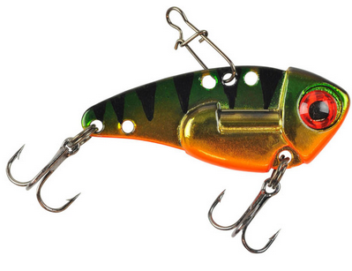

* Buzz fishing lures - safety pin lures for surface fishing that have a propeller blade on one piece of wire and a weighted body, skirt and hook on the other

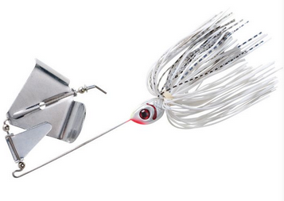

* Crank lures aka crankbait - fish like hard lure or plug designed to swim under the surface

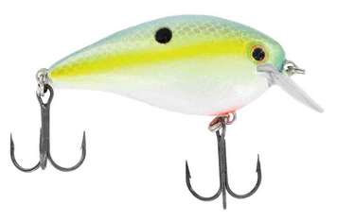

* Tube lures - tubular freshwater lures are fished with special weighted hooks inserted into the hollow body

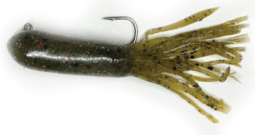

* Vibrating lures - contains a tiny motor that sends out sound-producing vibration to attract fish
* Snag hooks - heavy duty treble hooks that are weighted with lead around the center shanks of the three treble hooks.

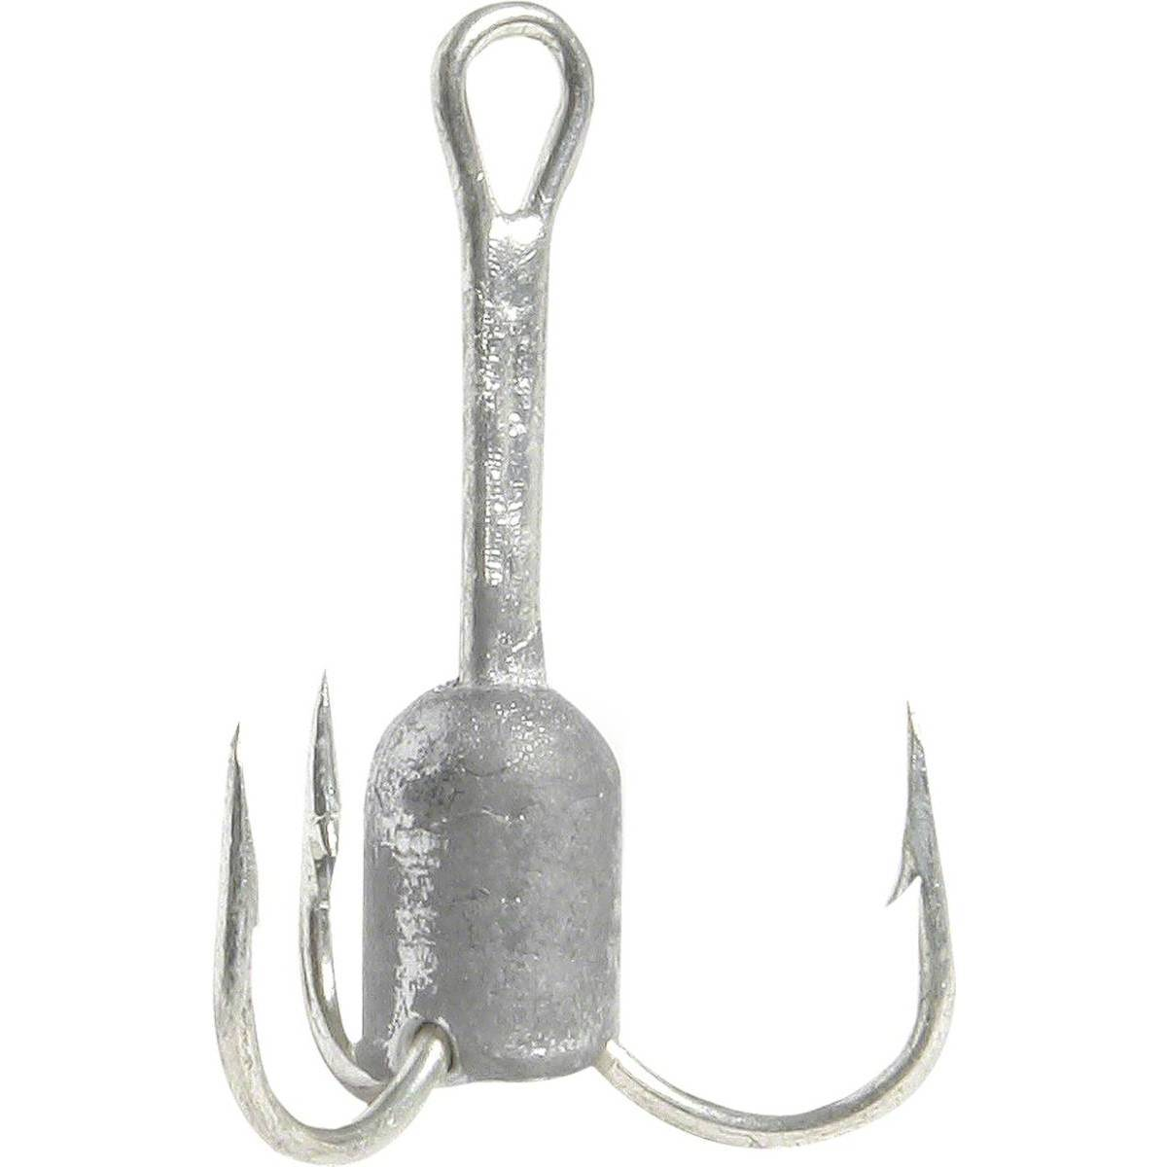

**Fishing Locations**

Freshwater (Rivers)

* Calm areas or eddies - rivers move strong and quick; fish seek refuge in the calmer backwater areas
* Stumps and vegetation - areas underneath overhanging branches aor bushes are good spots because they offer shade and protection from birds and other predators
* Islands or rock piles - look for sandy islands or rock piles, that’s where the calmer waters are.
* Merging currents - focus on areas where there are current shifts and changes - merging currents, drop-offs, feeder springs or any place where the current slows and food sources can collect

Freshwater (Natural Lakes)

* Shoreline that contain patches of aquatic vegetation such as lily pads or reeds
* Focus on spots where there is a change of the thickness or type of vegetation (large game fish such as largemouth bass and northern pike like to hang out around there because of higher oxygen levels)
* Logs or rock piles

Freshwater (Man-Made Lakes)

* Focus on drop-offs, creek edges and ledges as that will be the deepest areas - fish will hang out there because they offer food, cover and a different water depths

Saltwater

* Saltwater inlet - deeper water and more fish, look for inlets linking the backwater to open water; can include shallow bars or rocks.
* Marsh or mangrove edgest - good place to target when fishing the flats. Look for water rushing in or out of a creek or estuary near the marsh or mangrove edges to find fish that are waiting to ambush bait
* Oyster bars and grass beds - backwater reefs that support the marine food chain; best technique to use with backwater fishing around these places involve suspending the bait over the rough bottom using a popping cork, top water lure or a jig.
* Channels, creeks and rivers - features the deepest water and often the best backwater fishing. The ideal place to catch a variety of fish like predatory game fish and bottom dwellers
* Tidal flats - sand and mut bottom tidal flats; shallow areas that are typically a few inches to a few feet deep; commonly found in estuarine areas and are highly productive for fishing
* Potholes - located within the grass flats that are void of grass - have sandy or muddy bottoms. Good areas for saltwater game fish such as redfish or sea trout.
* Pilings - oysters, barnacles and small marine plants live on the pilings and rocks - great place for larger predatory fish
* Seawalls or bulkheads - good pier fishing because there are plenty of hiding places for bait and fish
* Troughs - where waves break off the beach - area contains fast-moving current where the baitfish and crustaceans will most often be found
* Jetties and breakwaters - best for surf fishing
* Points - natural sand or land formations that protrude out into the ocean and create an area of current where game fish can corral baitfish.
* Baitfish patches - if the angler can spot a school of baitfish, they might be able to catch bigger fish. Game fish strike fast and leave. Look for openings or lighter colored circles in the schools of bait.
* Schools - schools of baitfish
* Birds - birds fly above slow-moving baitfish - if they are thrashing around, angler should fish shallow.
* Breakers - calmer waters between the place where big waves crash and calm water starts - creates a trench where food settles.

**New York Waters**

* Fresh and saltwater fishing is available in NY
* 7500 lakes and ponds
* 70,000+ miles of rivers and streams
* Hundreds of miles of coastline
* DEC operates 12 hatcheries in NY and stocks more than 2.3M catchable trout (brook, brown and rainbow) in 309 lakes and ponds and 2,9000 miles of streams across New York State each spring

**Common Fish Species Found in New York**

1. Smallmouth Bass - second largest member of the sunfish family, attaining a weight of 12+lbs
2. Brook Trout - most popular game trout in North America
3. Largemouth Bass - most popular freshwater game fish in US
4. Striped Bass - relatively new game fish; it’s closest freshwater relatives are white bass, yellow bass and white perch
5. Bluefish - easy catch and very common in NY waters
6. Flounder - rapid swimmer; good light tackle game fish; most important flatfish in the Atlantic states

**Common Fish Species Details**

Smallmouth Bass

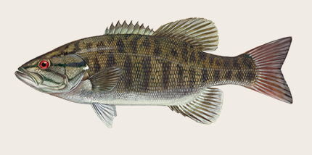

Region: Midwest, South, West, Northeast

Habitat: Lakes and ponds

Catch Ease: easy

Environment preferences:

* Clear and fast flowing streams
* Pools with gravel and/or rubble bottom
* If the fish shares habits with largemouth bass, largemouth bass will always spawn earlier because they nest in shallower and warmer areas. Smallmouth bass tend to live in deeper and more rocky areas.

How to Catch:

* Drift fishing
* Still Fishing
* Trolling

Baits, Lures and Tackles:

* Insects
* Minnows
* Soft Plastics
* Spoons
* Jigs
* Plugs
* Spinner bait

Where to Catch:

* Gradual shores
* Inlets & outlets
* Piers, docks and pilings
* Spring Holes
* Walkways and bridges
* Holes
* Open water
* Shoreline shallows
* Sunken objects
* Freshwater weed beds

Brook Trout

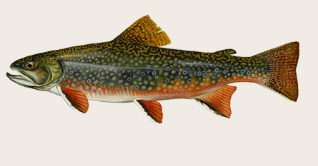

Region: Northeast, South

Habitat: Ocean, river, stream

Catch Ease: easy

How to Catch:

* Fly fishing
* Still fishing
* Bait casting
* Spin casting

Brook Trout Lures, Tackle & Bait:

* Cured fish roe
* Flies
* Insects
* Jigs
* Spoons

Where to Catch:

* Outsides of bends
* Riparian Zones
* Rock and boulder pockets
* Drop-offs
* Merging currents
* Standing waves
* Current edges
* Overhanging trees and bushes
* Rivers and streams
* Dams and falls
* Eddies
* Small pointed waves
* Undercuts

Largemouth Bass

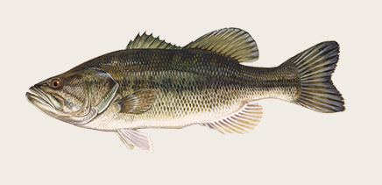

Region: Midwest, South, Northeast and West

Habitat: Lakes and ponds

Catch Ease: easy

How to Catch:

* Drift fishing
* Trolling
* Still fishing

Largemouth Bass Lures, Tackle & Bait

* Insects
* Minnows
* Soft plastics
* Spoons
* Jigs
* Plugs
* Spinner bait

Where to catch:

* Gradual shores
* Inlets and outlets
* Piers, docks and pilings
* Spring holes
* Walkway and bridges
* Holes
* Open water
* Shoreline shallows
* Sunken objects
* Freshwater weed bed

Striped Bass

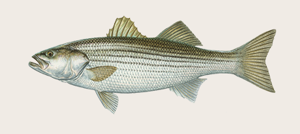

Region: Northeast

Habitat: Bay, ocean, river

Catch Ease: Medium

How to Catch:

* Jigging
* Fly fishing
* Surf casting
* Drift fishing
* Trolling
* Still fishing

Striped Bass Lures, Tackle & Bait

* Clams
* Cut bait
* Jigs
* Crabs
* Flies
* Plugs

Where to Catch:

* Backflow
* Breakers
* Jetties and breakwaters
* Outside of bends
* Schools
* Birds
* Coastal waters
* Night fishing
* Ripples, currents, swirls and sprays
* Current edges

Bluefish

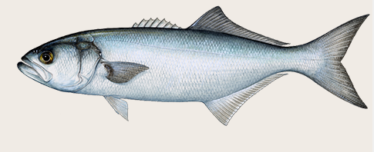

Region: Northeast, South

Habitat: Bay and ocean

Catch Ease: Easy

How to Catch:

* Jigging
* Trolling
* Still fishing
* Drift fishing
* Surf casting

Bluefish Lures, Tackle & Bait

* Jigs
* Saltwater live bait
* Spoons
* Plugs
* Spinner baits
* Squid

Where to Catch:

* Backflow
* Bays and estuaries
* Breakers
* Man-made structures
* Ripples, currents, swirls and sprays
* Bays
* Birds
* Channel entrances
* Merging water
* Schools

Flounder

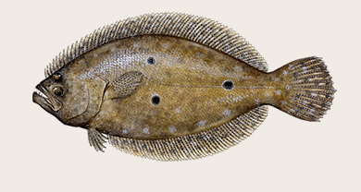

Region: Northeast, South

Habitat: Bay and ocean

Catch Ease: Easy

How to Catch:

* Jigging
* Bottom bouncing
* Saltwater jigging
* Drift fishing
* Still fishing

Flounder Lures, Tackle & Bait

* Cut bait
* Saltwater live bait
* Squid
* Jigs
* shrimp

Where to Catch:

* bays
* Channel entrances
* Bays and estuaries
* Man-made structures

**Other Fish Species Found in New York**

* Bluegill
* Carpies
* Walleye
* Perch
* Brown Trout
* Rainbow Trout